**Johnson & Johnson Open Innovation**

**Laurent TONNELIER**

**Johnson & Johnson / mobiLead Partnership**

**February 29, 2016**

**“Smart Packaging and IoT Platform”**

Interactive packaging, unitary tracking, brand protection and anti-counterfeiting solutions

C:\Documents and Settings\Laurent T.LAURENT-11A161F\Bureau\carte_visite\mobilead.emf



[Introduction 1](#_Toc444525067)

[Partnership 5](#_Toc444525068)

[Lesson from the past 6](#_Toc444525069)

[Johnson & Jonhson / mobiLead Partnership 8](#_Toc444525070)

[Definition / Topics 8](#_Toc444525071)

[Organization 9](#_Toc444525072)

[mobiLead 10](#_Toc444525073)

[About mobiLead 10](#_Toc444525074)

[Product Positioning 11](#_Toc444525075)

[Company Mission/Objective 11](#_Toc444525076)

[Business Model 11](#_Toc444525077)

[Market 12](#_Toc444525078)

[Competition, and your competitive advantage 12](#_Toc444525079)

[Recognized Expertise 13](#_Toc444525080)

[Business accomplishments 14](#_Toc444525081)

[Johnson & Jonhson / mobiLead Partnerships 15](#_Toc444525082)

[J & J / mobiLead Relationships 15](#_Toc444525083)

[Universities 15](#_Toc444525084)

[Innovative subjects 16](#_Toc444525085)

[Technologies 16](#_Toc444525086)

[Driven by Innovation, a unique and original approach 16](#_Toc444525087)

[Visual References add-ons 17](#_Toc444525088)

[Innovative subjects / QR Code + NFC 17](#_Toc444525089)

[Innovative subjects / Advanced QR Code on CPG 18](#_Toc444525090)

# Introduction

### MOBILEAD

**Interactive packaging, unitary tracking, brand protection and anti-counterfeiting**

Since 2008, MOBILEAD develops and operates an exclusive NFC and QR Code tag Management Platform that makes linking upwards of billions of individual manufactured objects, products packaging, and documents to value added online services cost effective and secure.

The company is strongly focused on meeting the unique requirements of production printers, CPG companies, and manufacturers.

The MOBILEAD system was designed from the ground up to support large scale, optimized printing, marking and tracking of QR Codes on billions of unique manufactured objects, documents, and consumer goods using today’s and tomorrow’s variable marking and printing technologies.

C:\Documents and Settings\Laurent T.LAURENT-11A161F\Bureau\afnor.emf D:\Dropbox\_mobiLead IMAGES REFs\logos\iso.emf D:\Dropbox\_mobiLead IMAGES REFs\logos\iso.emfw3cmember-v.emf

MOBILEAD is an expert group leader on NFC, QR Code and the Internet of Things (IoT) at AFNOR, member of ISO. MOBILEAD is a member of W3C and participates in GS1 Working Groups.

MOBILEAD is working in several axis

* On the appearance of each Visual QR Code: QR plus (QR+);
* On the way to select the tailored policy to Unique Identification and Serialization;
* On the way to manage billions of unique Identifiers on the server side (xTag);
* On the way gather and embed some meaningful information in each Unique Identifier (zTag: geocoding information; temporal information; application specific data; codification and encryption)
* On the way to secure each Identifier (jTag);
* On the way to provide “on line” and “off line” Applications to leverage information in each Unique Identifier
* On the way to design and develop innovative usages with partners, brands, and product manufacturers.

From innovative ideas, secrets, patents, software products and services, MOBILEAD wants to go further on a larger scale to provide a new approach to the packaging Unique Identification, in order to design and develop meaningful and usable services.

### An innovative approach

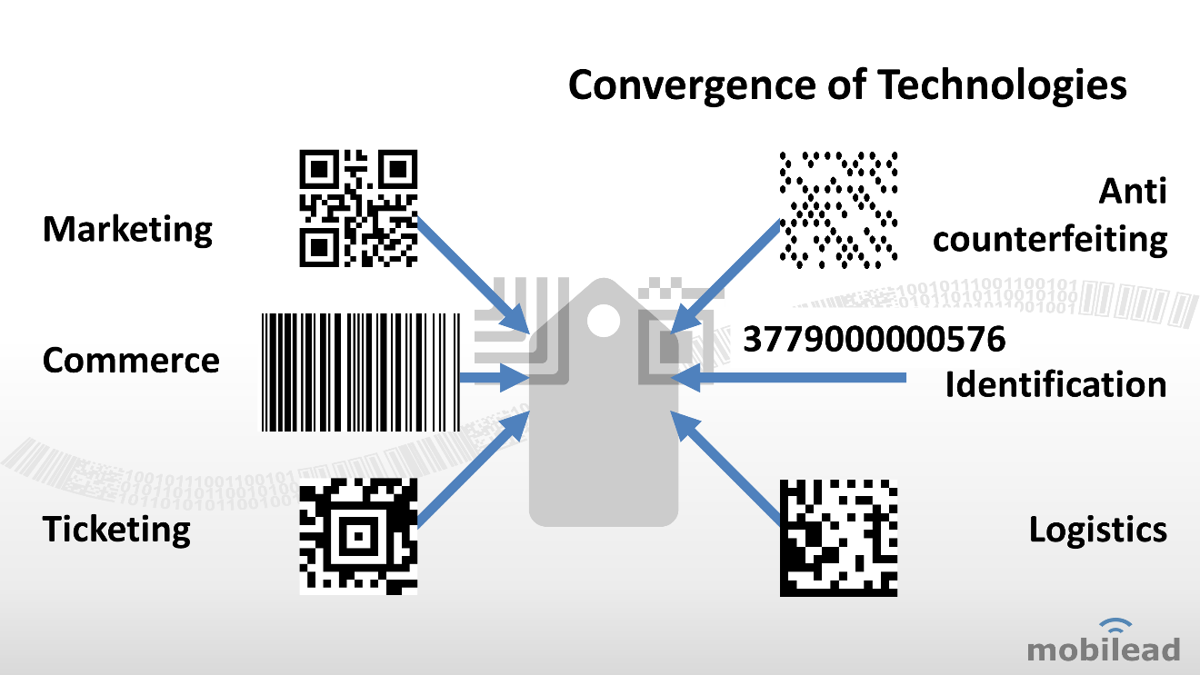

We do believe in the convergence of technologies into a Unitary Identification approach**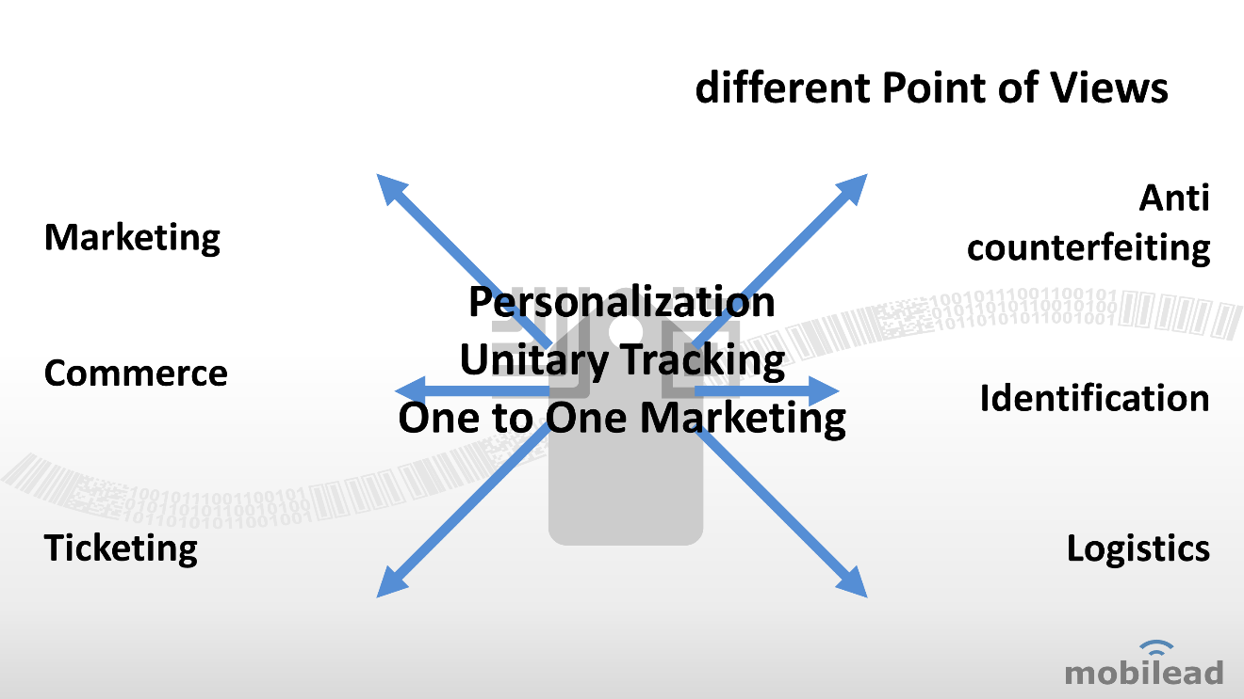**

The very same QR Code (resp. the very same NFC Tag), may have several usages; some public, some private; as a B2B tool, as a B2C tool…

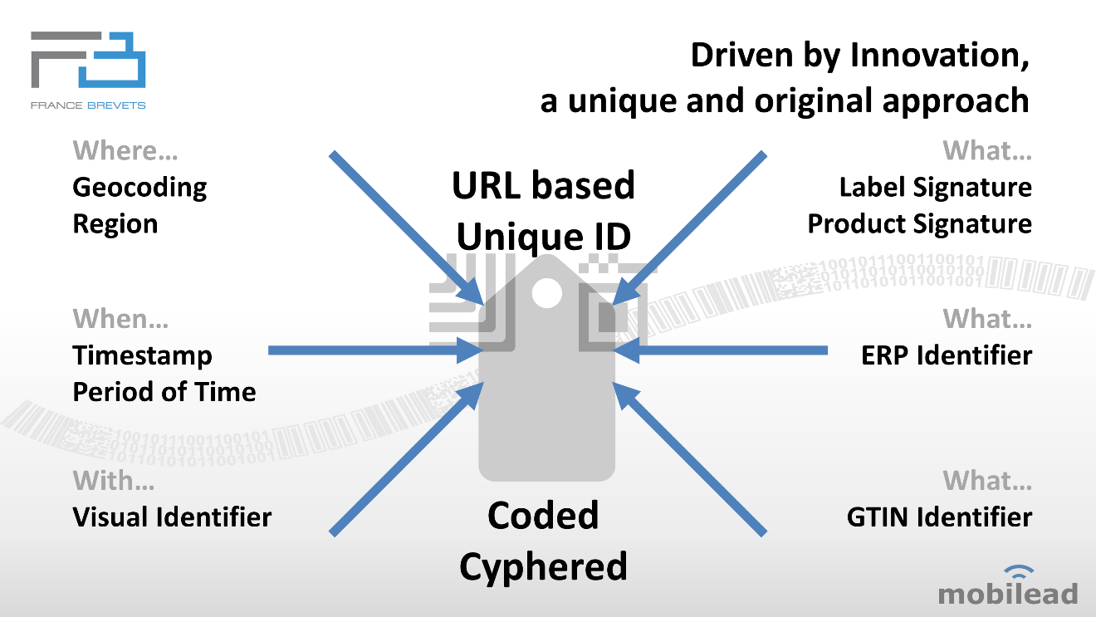

### In the field of Consumer Package Goods (CPG)

In 2015, MOBILEAD, in partnership with SQUARE and ABOUT GOODS, unveils at GS1 event a breakthrough in the way to create and manage QR Code Identifiers on Packaging.

**Not only**, the BLEDINA QR Code Identifier is a direct marketing URL link to the product catalogue managed by BLEDINA and DANONE, **but also** the QR Code Identifier holds the GS1 GTIN number of the product and the ERP Identifier (SAP).

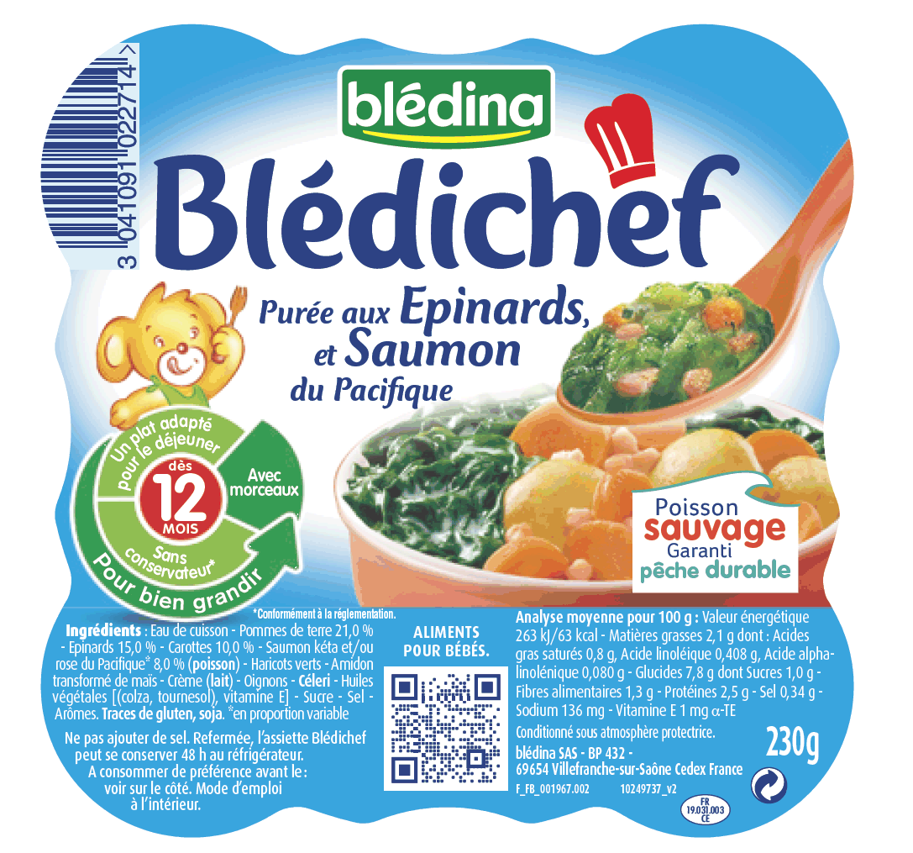

MOBILEAD, is now working of the way to merge Unique Identification and Serialization on packaging.



#### Ingredients / Allergens

MOBILEAD, member of AIPIA, has designed, and prototyped, an innovative and disruptive approach to ingredients and/or allergens information given to the end user, enabling an immediate, private and reliable access to personalized information from a mobile phone or any other system able to read, decrypt, decode and process this kind of QR Codes.

### In the field of Pharmaceutical Packaging

In 2015, in partnership with GS1 and BIOGARAN, in conjunction with ORACLE, MOBILEAD has been working of the way to leverage the supplementing Directive 2001/83/EC.

#### May

*(14) The presence of multiple two-dimensional barcodes on the packaging* ***can*** *engender confusion... This* ***may*** *lead to mistakes in the verification of the authenticity of medicinal products... For this reason, the presence of multiple two-dimensional barcodes on the packaging of a medicinal product* ***for the purposes of identification*** *and verification of the authenticity* ***should be avoided****.*

#### Shall

*Article 5 - Carrier of the unique identifier*

*1. Manufacturers* ***shall*** *encode the unique identifier in a two-dimensional barcode.*

*2. The barcode* ***shall*** *be a machine-readable Data Matrix and have error detection and correction equivalent to or higher than those of the Data Matrix ECC200...*

# Partnership

### Context

The initial goal of such partnership is to investigate new developments to MOBILEAD’s “Smart Packaging and IoT Platform” while providing to JOHNSON & JOHNSON new solutions and a real time to market advantage. It is a proactive and innovative approach that provides a unique environment to prototype, test products and business models prior to any commercial introduction on a large scale.

The major goals to achieve are the following one:

* Extend MOBILEAD’s “Smart Packaging and IoT Platform” – connected and disconnected – with high-value technologies grounded by one, or many, key brand and/or product’s requirements.
* Test this extension by deploying it in the brand / product environment.
* Explore in a joint approach new and innovative areas to investigate.
* Give to JOHNSON & JOHNSON a shortcut access to MOBILEAD’s innovations, Intellectual Property and early stages Prototypes.
* Provide to JOHNSON & JOHNSON a real time to market advantage and real experience in new and innovative technologies.

### Proof by example

Better than any talk, a proof of concept is the strongest approach. Brands are looking for innovative solutions and key partners that are able to build them. The strength of MOBILEAD is to rapidly take a prototype and build a product and a business for it.

The value in our prototypes will be to find the good fit between our partners and some advanced subjects that have to be investigated. The JOHNSON & JOHNSON / MOBILEAD partnership could be that enabler.

### Partnerships

Partnerships with Variable Digital Printing companies (including HP), Variable Digital Marking companies (including DOMINO), hardware vendor (including COGNEX), software industries (including ORACLE) and DENSO WAVE – inventor of the QR Code - will be key. Unfortunately, the window allowed to take an active part in that schema is really short. Partnerships, prototypes have to be done as soon as possible. In that schema, Partnership do have a key role to play to design and experiment what the near future could be.

# Lesson from the past

### ORACLE / TELIA joint initiative

In 1999, Laurent TONNELIER, now CEO of MOBILEAD, helped ORACLE productize a wireless Internet portal jointly developed by Swedish mobile carrier TELIA and ORACLE.

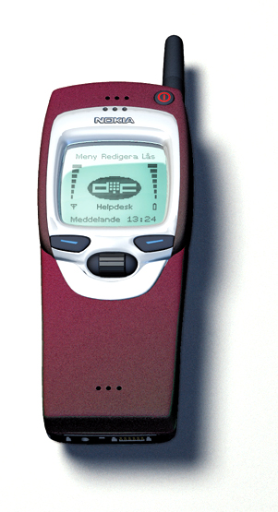

In order to break a vicious circle where no devices where available neither services, TELIA and ORACLE created a joint development Lab based in Sweden. An advanced group of highly skilled engineers from ORACLE and TELIA was set up in Sweden. ORACLE gave a full access to its development team. TELIA gave a full access to their network and facilities. In few months the team came we the first XML portal ever built.

This prototype was intensively used by ORACLE to design and develop what became ORACLE 9iAS Wireless Edition, formerly known as Portal-to-Go. This approach gave to ORACLE a real advantage on the Wireless market and to TELIA the best way to show their ability to innovate.

Later on, we proudly announced and demonstrated at Telecom 99 in Geneva, a unique European professional event that takes place every 4 years in Switzerland, the following:

* First Voice access to a Wireless portal, using MOTOROLA VoxML language;
* First Location Based Services on ERICSSON wireless network;
* First Home appliances interface, using SUN Jini technology.

Designed to deliver content for browser based mobile devices from existing Internet websites, ORACLE extended that product to more Markup Languages such VoiceXML, cHTML (iMode), and other contents such as SQL databases, LDAP server. Recently, was added to this portal, native Location Based Services and Business Intelligence features.

Portal-to-Go was the foundation for two ORACLE spin-offs that opened up the platform as online services letting carriers rapidly design hosted white label wireless Internet portals: ORACLE Mobile in the United States and DRUTT in Europe, a TELIA- ORACLE joint venture acquired by ERICSSON in 2007.

The benefits of such prototype Labs are numbers: Business, Marketing and Product.



### Business opportunities

A prototype lab offers to ORACLE the best way to understand a given market, its complexity. As it involves different key players such as MOTOROLA, ERICSSON or SUN, it is also a place to try third part products and its integration with ours. This first lab with TELIA gave us a name in the Wireless world. From that initiative we were able to offer to carriers a product already used by one of them.

### Marketing event

CEBIT, TELECOM99 and CES were the place to show our technology in action. For each of those events, we had an impressive press coverage. In the wireless world innovators are the leaders. Those marketing events gave us an important mind share in the Wireless market, what we didn’t had before.

### Product enhancement

A lab gives to the product a real environment to test and improve our software prior to release any product. This kind of partnership brings a unique opportunity to run the software and to improve what has to be.  
By a better understanding of the usage of the software, the needed integrations and early feedbacks from the end user, a prototype lab is the best way to insure high quality softwares.

# Johnson & Jonhson / mobiLead Partnership

## Definition / Topics

What a JOHNSON & JONHSON / MOBILEAD Partnership is not:

* A day-by-day support to an existing project;
* Some free consulting.

What it is:

* A nice association of innovative technologies and subjects, hosted by a specific brand / product ready to try, deploy and communicate on that innovation later on.

Knowing the specific features that are needed in our solution, we should be able to select what should be found in a partner product or developed by us as part of our solution. Prototypes should be done in our different Labs to cover the missing pieces in our offer.

A JOHNSON & JONHSON / MOBILEAD Partnership offers to MOBILEAD the best way to understand a given market, its complexity. As it involves different key players such as HP, DOMINO, COGNEX, ORACLE and SAP, it is also a place to try third part products and its integration with ours.

Each packaging hold a Unique Identifier either stored in an optical readable QR Code or a radio readable NFC Tag.

The following technologies and innovative subjects that could be investigate are detailed in this document:

* On the way to manage billions of Identifiers
* On the content of each Unique Identifier
  + Geocoding information;
  + Temporal information;
  + Application specific data;
  + Codification, encryption;
* On line / Off line approaches…
* On the appearance of each QR Code (Visual)

The very same QR Code (resp. the very same NFC Tag), may have several usages; some public, some private; as a B2B tool, as a B2C tool…

## Organization

A partnership requires a joint approach where both parties bring well skilled people, on the JOHNSON & JOHNSON side and the MOBILEAD side.

In order to avoid jeopardizing the joint development if one of the only developer leaves the project, the team should be a minimum of 2 software developers.

* Primary Androïd and IOS Mobile Clients*, Secondary on Server*
* Primary Server*, Secondary on Androïd and IOS Mobile Clients*

#35 K€ / developer / year

In order to avoid re-inventing the wheel, a swat team has to be created.

This group has to share the knowledge that could be shared, and will act as an adviser. This group will package existing demos and prototypes already available and give them to the specific brand / product line / product that is looking for such a content.

Resource on the MOBILEAD side could come from:

* Permanent employee (hired or transferred);
* High skilled student during a specific internship.

Resource could come from technical Partners (ORACLE, HP, DOMINO…)

* Consulting;
* Pre sales (on a short term period).

Inputs of partnerships are:

* Product new areas investigation;
* Product validation in a new environment;
* Marketing needs to emphasis MOBILEAD and JOHNSON & JOHNSON presence.

Deliverable of partnerships are:

* Prototypes to give technical inputs and validations to our dev. team;
* Technical specification to improve our products;
* Packaged prototypes for marketing events such as “DRUPA” or “LABEL EXPO”.

# mobiLead

## About mobiLead

### mobiLead’s CEO

Laurent TONNELIER is co-founder and CEO of MOBILEAD, an innovative software company able to connect corporations with end users, consumers or patients through objects, using optical and radio frequency identification systems.

A serial innovator and mobile industry veteran, Laurent was one of the key architects behind ORACLE’s mobile Internet strategy. Starting in 1998, as Principal Product Manager for ORACLE Wireless & Embedded Products, Laurent helped ORACLE productize a wireless Internet portal jointly developed by Swedish mobile carrier TELIA and ORACLE.

Portal-to-Go, the software product developed by ORACLE under Laurent’s product management leadership, was one of the first software products to let carriers and enterprises deploy mobile Internet portals. Portal-to-Go was the foundation for two ORACLE spin-offs that opened up the platform as online services letting carriers rapidly design hosted white label wireless Internet portals: ORACLE Mobile in the United States and DRUTT in Europe, a TELIA-ORACLE joint venture acquired by Ericsson in 2007.

Starting in 1998 and to this day, Laurent has been convinced of the need for all mobile Internet stakeholders to collaborate on the definition of open mobile Internet standards. During his tenure at ORACLE, he was involved in several W3C initiatives (including XHTML-MP, CSS-MP) aimed at defining mobile Internet and Web services standards.

### Laurent Tonnelier, CEO

* (Microsoft, Oracle Corp, CNES, Essilor/Varilux)
* Postgraduate degree in Adv. Databases and IT MSCS

### Ludovic Lebas, CTO

* (Business & Decision, Fatwire, OpenMarket, Oracle France)
* Postgraduate degree in Adv. Databases

### Christian Bonnin, Marketing

### **Louis Mercier, Finance**

### Sylvie Rieu, Business Development

## Product Positioning

There is much buzz these days about “active objects” connected to the Internet of Things (IoT). MOBILEAD believes that active connected objects will represent the tip of the iceberg of the Internet of Things. Much more prevalent will be individually marked “passive” manufactured objects, documents, and consumer packaged goods that are each connected to value added mobile services.

The security risks in the Internet of Things field cannot be treated without significant innovations in software technology and architecture. Solutions must also address some critical challenges such as privacy by design, interoperability, performance and scalability.

MOBILEAD is a world pioneer in advanced generation and secure management of highly graphical QR Codes thanks to its patented QR plus (QR+) technology, the ISO compliant Visual QR Code.

* The innovative and patented technology allows the merging of a regular QR Code with any image, picture or logo into a highly graphical ISO/IEC 18004 compliant code to be read by any QR Code device.
* MOBILEAD is a member of the AFNOR/ISO (CN31 AIDC) normalization commission and an expert group leader on NFC, QR Code and the Internet of Things (IoT) at AFNOR, the French national organization for standardization, a member organization of the International Organization for Standardization (ISO).
* MOBILEAD is an expert on NFC, QR Code and the Web of Things (WoT) at the World Wide Web Consortium (W3C).

## Company Mission/Objective

MOBILEAD, 2014 Red Herring Europe Top 100 winner, develops and operates an exclusive Identifiers cloud-based Tag Management Platform that makes linking upwards of billions of individual manufactured objects, product packaging, and documents to value added online services cost effective and secure.

Since its foundation, MOBILEAD has pursued a steadfast vision to enable industrial scale production, management, and tracking of unique identifiers on millions of documents, manufactured objects and consumer goods.

MOBILEAD’s unique vision is now coming to fruition.

## Business Model

MOBILEAD’s growing momentum with standard bodies, industrial and commercial partners, and enterprise customers together form the foundation upon which the company may base its expansion as it goes after the largely untapped blue ocean market for connecting all the world’s customer facing documents, manufactured objects, and CPG goods to value added online services.

* The company got its unique vision heard and discussed by leading standard bodies that include the W3C, GS1, AFNOR, and ISO along with analyst firm Forrester Research.
* The company is well advanced in striking partnerships with industrial leaders that include Arjowiggins, HP, ISRA Cards, Paragon Identification and Domino.
* The company scored enterprise customer wins at Natixis Bank, SFR, Bouygues Telecom and Blédina.

Company's Biggest Challenge Moving Forward

* + - * One of the company’s key challenges will be to further develop its Intellectual Property and innovate to advance its technological lead versus competitors.
      * The company also needs to strengthen its network of partners who embed its branded zTag, xTag and QR+ technologies into their products and services.
      * The company needs to grow out of its home market from France and expand internationally.
* MOBILEAD may create and manage QR Codes and NFC tags for its customers as an end-to-end managed service. Clients may monitor the performance of their QR Codes and NFC tags using a convenient online interface.
* MOBILEAD may provide an appliance that offers its QR Code and NFC tag creation and management capabilities for on premise deployment next to its clients’ variable digital production printers and markers.
* Also, MOBILEAD licenses its full Intellectual Property (patents, trademarks, and design model) through FRANCE BREVETS

## Market

MOBILEAD has initiated a network of partners, each recognized international specialists in their field, who embed the company’s unique QR+ and xTag technologies into their Internet of Things or printing offerings.

* NFC label converter GSTAG now offers a combined QR+ and NFC label solution powered by MOBILEAD.
* ISRA Cards now offers NFC cards and window stickers that are printed with a unique QR+.
* MOBILEAD works with HP and DOMINO to provide QR+ an xTag generation and management as a standard pre-installed service on their production printers.
* Variable digital marking leader DOMINO will soon offer high speed, high definition marking of industrial objects with QR+ and xTag codes.
* MOBILEAD is in discussions with Konica Minolta and Xerox.

The QR+ and xTag brands must be used by all partners as they brand their respective offerings.

## Competition, and your competitive advantage

As a FRANCE BREVETS selected partner, an investment fund dedicated to international patent licensing, MOBILEAD holds several patents in the Internet of Things field, enabling the creation and management of billions of unique and secured identifiers.

MOBILEAD is involved in interactive packaging, unitary tracking, brand protection and anti-counterfeiting solutions.

## Recognized Expertise

Influential Forrester Research analyst Thomas HUSSON endorsed the company’s vision.

C:\Documents and Settings\Laurent T.LAURENT-11A161F\Bureau\forest.emf

« However, moving forward, we expect QR Codes to gain traction and to be increasingly mixed with other technologies (including radio technologies like NFC) to provide extended product packaging solutions. Bar codes do not have to be just cold, emotionless, black-and-white squares. Solutions now exist to personalize QR Codes’ designs and seamlessly mix them into a logo or band chart – even merging QR Codes and NFC tags, as in the example below from MOBILEAD solutions.  »

*Thomas HUSSON, Forrester Research*

« Radio and optical technologies are converging, as highlighted by French startup MOBILEAD, which does a fantastic job of delivering a great branded experience mixing QR Codes and NFC tags »

*Thomas HUSSON, Forrester Research*

*D:\temp\axicon_logo.wmf*

« The QR plus technical feat of strength puts mobiLead well ahead of the competition. »

*Bruno Rolland Axicon, Barcode Expert*

## Business accomplishments

MOBILEAD, 2014 Red Herring Europe winner, has been selected as a candidate for Red Herring’s 2014 Top 100 Global award, a prestigious recognition honoring the year’s most audacious and far-reaching private technology companies and entrepreneurs from across the globe.

MOBILEAD was selected by FRANCE BREVETS, an investment fund dedicated to international patent licensing.

Because of its commitment to promoting standards and best practices, its technical expertise, MOBILEAD joined the SYSTEMATIC cluster**, and its technology group Digital Trust and Security.**

The company scored significant enterprise customer wins:

* + - * Natixis Bank (73,000 QR+ NFC window stickers / 450,000 unique URL links)
      * Natixis Bank (QR+ on 300 distinct types of customer facing documents)
      * William Saurin (QR+ GTIN on all Petit-Jean and Garbit branded products in Europe)
      * Mapa Spontex
      * Bouygues Telecom (QR+ on 200 distinct types of marketing and advertising documents)
      * SFR (25,000 NFC and QR+ building control tags at SFR’s HQ in Saint Denis)
      * Blédina / Danone (QR+ GTIN on all Blédina products)

The company became a GS1 partner to assist in the authoring of a worldwide reference document on best practices for printing QR Codes on CPG products.

MOBILEAD became an expert group leader on NFC, QR Code and the Internet of Things (IoT) at AFNOR, the French national organization for standardization, a member organization of the International Organization for Standardization (ISO).

Influential Forrester Research analyst Thomas HUSSON endorsed the company’s vision.

MOBILEAD is currently involved in the authoring of an AFNOR reference document on guidelines for printing QR Codes.

MOBILEAD joined the Worldwide Web Consortium (W3C) as an expert on NFC, QR Code and the Web of Things (WoT)

MOBILEAD joined the AIPIA (Active and Intelligent Packaging Industry Association)

# Johnson & Jonhson / mobiLead Partnerships

## J & J / mobiLead Relationships

Business

In order to test a set of new services with real products, MOBILEAD is able to do some joint test with JOHNSON & JOHNSON and some selected Brands.

Third party Partners

In order to experiment their technology, common partner such as ORACLE, HP or DOMINO are ready to test a new approach, new innovative products with JOHNSON & JOHNSON and MOBILEAD.

Hardware manufacturers such as COGNEX are ready to have a joint approach with JOHNSON & JOHNSON and made the proposal to get an early access to their prototypes.

## Universities

Student brings a deep investment and a fresh blood to projects. As soon a legal issues are solved in order to avoid any disclosure, advanced projects could start at low costs.

# Innovative subjects

## Technologies

Technologies and innovative subjects that could be investigate are:

* On the way to manage billions of Identifiers
* On the content of each Unique Identifier
  + Geocoding information;
  + Temporal information;
  + Application specific data;
  + Codification, encryption;
* On line / Off line approaches…
* On the appearance of each QR Code (Visual)

## Driven by Innovation, a unique and original approach

### Not Only…

We are able to create hundreds, thousands, millions, billions of unique URL Links. We are able to provide Unique Identifiers (UIDs), Unique URLs, Unique Tags (QR Code, NFC)

### ... But also

We are able to manage each link on the serveur side, on premise, or locally.

### Not Only…

We do believe in Research and Development, Intellectual Properties

### ... But also

We are willing to share our IP with others, to be part of Norms, Standards and Best Practices – including Open Innovation. We are able to provide integrated solutions, software licences, algorithms, patent IP licences thru FRANCE BREVET

### Not Only…

We are able to create Unique URL links, either QR Code or NFC tag, to personalized and tailored content. We are able to provide remotely on a distant machine such a MDM product information server

### ... But also

We are able to create Unique Identifiers (UID) that contains coded and cyphered information. We are able to provide local information, or premises, without network required.

# Visual References add-ons

## Innovative subjects / QR Code + NFC

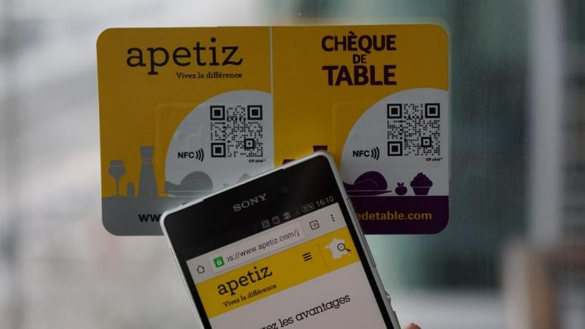

C:\Documents and Settings\Laurent T.LAURENT-11A161F\Bureau\sfr.emfC:\Documents and Settings\Laurent T.LAURENT-11A161F\Bureau\Schneider_Electric.emf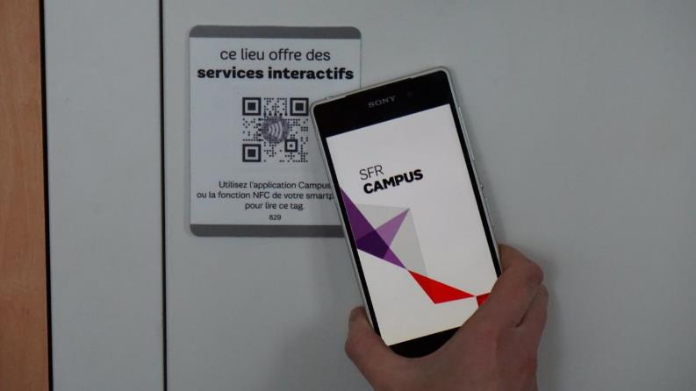

C:\Documents and Settings\Laurent T.LAURENT-11A161F\Bureau\repertoires\Cité des Sciences\Cité_des_sciences.emf 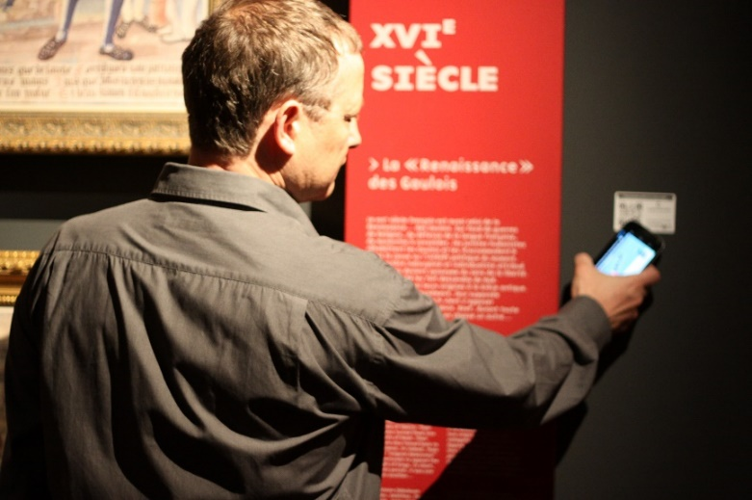

## Innovative subjects / Advanced QR Code on CPG

  D:\Dropbox\mobiLead - Clients - Prospects\William Saurin - Panzani\PetitJean.emf

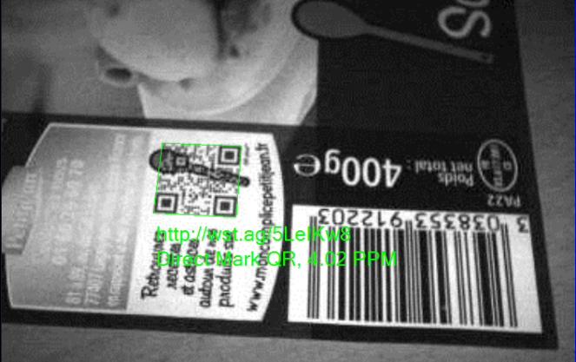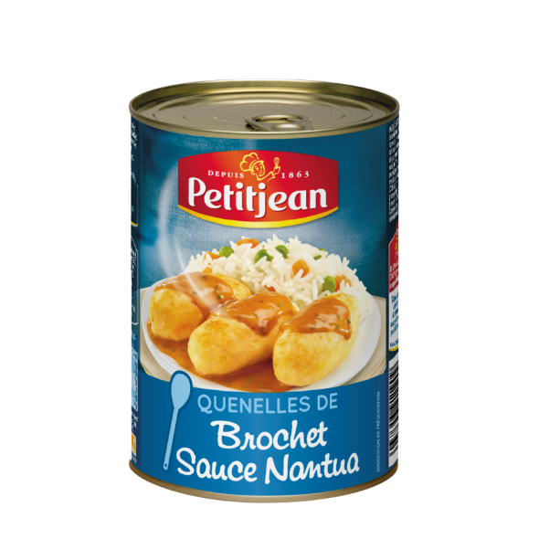

C:\Users\laure\AppData\Local\Microsoft\Windows\INetCache\Content.Word\Bledina_all.emf

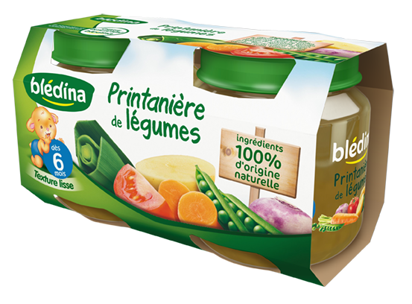

C:\Documents and Settings\Laurent T.LAURENT-11A161F\Bureau\carte_visite\mobilead.emf

**MOBILEAD SAS**

**104 avenue de France**

**75013 Paris - France**

**http://MOBILEAD.eu**

**Copyright © MOBILEAD 2016**

**All Rights Reserved**

This document is provided for informational purposes only and, the information herein is subject to change without notice. Please report any errors herein to ORACLE SAS. MOBILEAD does not provide any warranties covering and specifically disclaims any liability in connection with this document.

MOBILEAD is a registered trademark, QR+, QR plus and xTag are trademarks of MOBILEAD SAS. All other company and product names mentioned are used for identification purposes only and may be trademarks of their respective owners.