# SMART PACKAGING 2017

# SPEAKER REPLY FORM

19-20 September, Maritim Hotel, Cologne, Germany

**PLEASE COMPLETE AND RETURN THE FORM WITHIN 7 DAYS**

FAO: Emily Renshaw, Conference Organiser, Applied Market Information (AMI) Ltd.,

Fax: +44 (0) 117 311 1534 or Email: [er@amiplastics.com](mailto:er@amiplastics.com)

|  |  |
| --- | --- |
| **NAME:** | Mr Laurent TONNELIER |
|  | *(Mr/Ms/Dr/other, First name, Surname)* |
| **POSITION:** | CEO |
| **COMPANY:** | MOBILEAD - FTAG |
| **ADDRESS:** | 104 avenue de France |
|  | 75013 Paris - France |

|  |  |  |  |
| --- | --- | --- | --- |
| **PHONE:** | 0033 1 46 46 13 38 |  |  |
| **EMAIL:** | laurent.tonnelier@mobilead.fr | | |

|  |  |
| --- | --- |
| **TITLE OF PAPER:** | Smart Identifiers for the packaging in food industries is evolving in order to deliver a convenient, personalized, reliable, and thrusted information to consumers |
|  | *(Company, product names and trademarks are not accepted in paper titles)* |

**The above details will be used within the conference brochure and proceedings.**

*Please also supply a mobile telephone number, this will only be used to contact you regarding the paper and won’t be published.*

|  |  |
| --- | --- |
| **MOBILE:** | 0033 6 74 72 15 75 |

1. Will you attend the Networking Cocktail Reception on 19th September? Yes ☑ No ☐

2. Do you have any special dietary requirements? Yes ☐ No ☑

If yes, please state:

3. Would you like to receive printed copies of the conference brochure? Yes ☑ No ☐

If yes, please state how many: **1**__________________________

*As the author(s) of this paper or PowerPoint presentation, I authorise Applied Market Information Ltd. to use this PowerPoint presentation in the preparation of the conference proceedings for SMART PACKAGING 2017*.

*I agree that Applied Market Information Ltd. may publish the proceedings of the conference (including this paper) in hard copy and electronic formats and that the proceedings themselves will be published under an Applied Market Information Ltd. copyright. As the author I retain the rights to this presentation and permission from Applied Market Information Ltd. is not required in the event that this is published elsewhere.*

*I accept responsibility for obtaining copyright permission for materials to be used in my presentation including text and illustrations.*

*I understand I am liable for all expenses incurred as a speaker (including travel & accommodation)*

*Speakers can meet the Conference Organiser from 08.00hrs on 19th September 2017 to rehearse their presentation. Presentations will be run from a central laptop and LCD projector using PowerPoint only. I have read the enclosed notes for speakers and I understand that I must provide a copy of my PowerPoint presentation* ***no later than 28th July 2017.***

SIGNED: 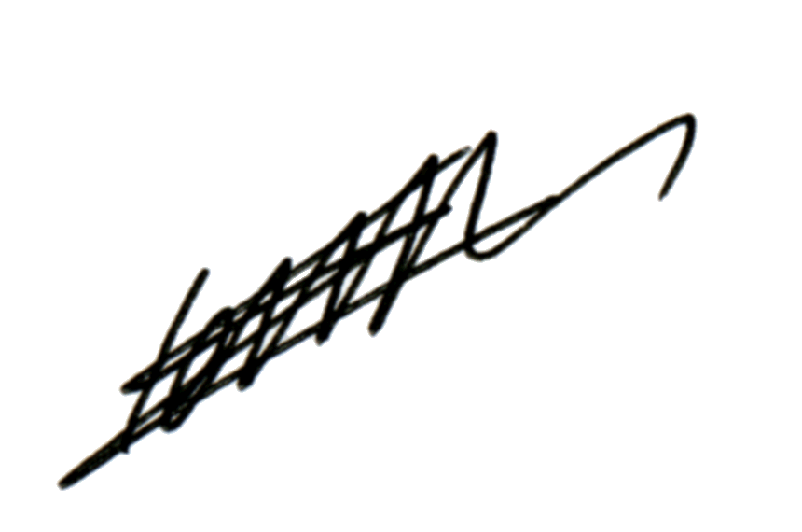 DATE: the 4th of April 2017.